Chapter 5 Populations
Section 1 Population Growth
- Characteristics of Populations
- 3 important characteristics of a population are its
- geographic distribution – describes the area inhabited by a population

- density – number of individuals per unit area

- growth rate – three factors affect population sizes – the number of births, the number of deaths, and the number of individuals that enter or leave the population
- population grows when its birthrate is greater tan its death rate
- population stays the same when birthrate = death rate
- population shrinks when death rate is greater than death rate
- immigration – the movement of individuals into an area→population grows
- emigration – the movement of individuals out of an area→ population drops
- another characteristic is the population’s age structure

- Exponential Growth
- occurs when the individuals in a population reproduce at a constant rate
- increases slowly at first →overtime the population becomes larger
- under ideal conditions with unlimited resources a population will grow exponentially
- J curve
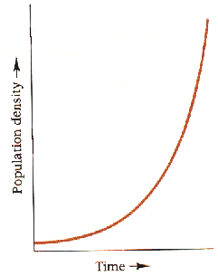
- Logistic Growth
- as resources become less available, the growth of a population slows or stops
- S – curve
- Populations go through a # of growth phases
A – initial growth – slow
B – begin to grow rapidly (few dying; many reproducing)
C – begins to slow (population is still growing but slowly)
D – grows more and more slowly
E – steady state – growth rate is 0
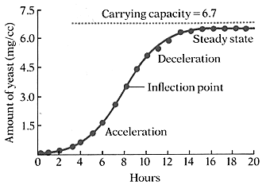
Carrying capacity – line through steady state
- factors keep population from growing
- food (lack), overcrowding, competition
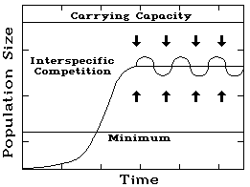

Section 2: Limits to Growth
- limiting factor – is a factor that causes population growth to decrease

- Density – Dependent Factors
- limiting only when the population density – the number of organisms per unit area – reaches a certain level
- most strongly when population is large and dense
- competition, predation, parasitism, disease

- predators and prey come accustomed to each others strengths and weakness
prey pop grows →predators pop grow →pred eat more prey than is born →prey pop decreases → predators starve →predator pop drops → few pred, prey pop increases → etc.

- crowding and stress

- Density – Independent Factors
- affect all populations in similar ways, regardless of the population size
- unusual weather, natural disasters, seasonal cycles, and certain human activities

- boom and bust growth curves
- grow fast then crash, rebuild and stay low for a period of time

Section 3 human Population Growth
- Like the populations of many other living organisms the size of the human population tends to increase with time
- Agriculture and industry made life easier and safer
- Food supply became more reliable
- Improved sanitation, medicine, and health care → increased longevity
- Exponential growth

- Patterns of Population Growth
- demography – scientific study of human populations – examines the characteristics of populations and attempts to explain how those populations will change over time

- birthrates, death rates, and age structure of a population help predict why some countries have high growth rates while other countries grow more slowly

- The US has completed demographic transition – a dramatic change in birth and death rate and the population has slowed dramatically
- Birth control
- Less farming → less need for children
- Increase level of education and raise their standard of living
- Demographic transition is complete when the birthrate falls to meet the death rate, and population growth stops.

- Age Structure
- population growth depends on how many people of different ages make up a given population

- age – structure diagrams – population profiles
- graph the number of people in different age groups in the population

Chapter 6 Humans in the Biosphere
- Among human activities that affect the biosphere are hunting and gathering, agriculture, industry, and urban development

- Environmental goods and services may be classified as either renewable or nonrenewable
- Renewable – regenerate or can be replenished
- Nonrenewable – cannot be replenished

- Human activities can affect the quality and supply of renewable resources such as land forests, fisheries, air and fresh water

- Soil erosion
- Desertification
- Deforestation
- Overfishing
- Smog
- Acid rain
- Water pollution

- Biodiversity is one of Earth’s greatest natural resources. Many species have provided us with foods, industrial products, and medicines

- Human activity can reduce biodiversity by altering habitats, hunting species to extinction, introducing toxic compounds into food webs, and introducing foreign species to new environments

- Habitat fragmentation
- Poaching and overhunting
- Biological magnification
- Invasive species

- Today conservation efforts focus on protecting entire ecosystems as well as single species. Protecting an ecosystem will ensure that the natural habitats and interactions of many different species are preserved at the same time

- Civilian Conservation Corps
- Endangered Species Preservation Act
- Earth Day
- Earth Summit
- National Marine Sanctuaries Act

- Researchers are gather data to monitor and evaluate the effects of human activities on important systems in the biosphere. Two of these systems are the ozone layer and global climate system
- Ozone Depletion
- Global Warming

